

Building Awareness of Enterprise:

The innovative ABW Enterprise Education Program



A summary report of eleven years
of independent evaluations

Geof Hawke
December 2010

About the author

Geof Hawke is a well-regarded researcher who has worked in vocational education and training for over thirty years in a wide range of capacities.
Geof was for twelve years a Senior Research Fellow in the Centre for Research in Learning and Change a key research centre within the Faculty of Education at the University of Technology, Sydney. In that time he published and spoke widely on matters concerning the Australian vocational education and training system and on his research on how vocational learning occurs.
Geof’s involvement with ABW began when he was contracted to undertake an independent evaluation of the 1998 ABW schools program. His involvement continued, however, with an ongoing role in working with ABW to develop suitable survey instruments and to annually produce an overall research and evaluation report on each year’s cohort.
Acknowledgements
The author is pleased to acknowledge the ongoing contribution to the evaluations that form the basis of this report of the staff of ABW’s national office. Over the years, all the staff of the office have willing assisted by helping to clarify data anomalies or to provide access to correspondence from schools, local press reports and the like.
In particular, thanks are due to ABW’s Chairman, Norm Owens and to General Managers, Sandra Ross and Glyn Evans. A special thanks, too, to Cassie Sargent who has answered so many of my questions.

© 2010 Australian Business Week Ltd.

Building Awareness of Enterprise:

The innovative ABW Enterprise Education Program

A summary report of eleven years
of independent evaluations

Geof Hawke
December 2010

Contents
Executive summary 1
Introduction 2
Australian Business Week 2
So what is ABW Enterprise Education? 3
The simulations 4
The Evaluations 6
The initial evaluation 6
Subsequent evaluations 6
How the data has been used in this report. 7
The size and scope of the program 8
Participation by System Type and Location 9
The school year from which students are drawn 10
The Students 12
Participant Age and Gender 12
Other demographic descriptors of the student participants 12
Student expectations about business and enterprise 13
Business Attitude Scales 15
Teacher, Business Mentor and Parent Views 17
Teacher views 17
Business views 19
Parent views 20
What Students Think of the Program 21
What the students say 22
How Students’ Knowledge and Attitudes Change After the Program 24
Changes in individual questions 24
Changes in student attitudes 25
Some Explorations of the Influence of Demographic Variables 28
Impact on student experience of business 28
Effects on pre-post change 29
Conclusions 32
References 33

Executive summary
The ABW Enterprise Education program for schools has been operating continuously since 1994. In that time more than 200 secondary schools throughout Australia and over 134,000 individual students have participated.
The program is an intensive, one-week enterprise-education program in which students form small companies and these compete with each other through eight business quarters (two years) that are modelled within one of a number of simulations reflecting different industry sectors.
Since the 1998 cohort, the program has been continuously monitored and the subject of an independent evaluation by educational researchers from the University of Technology, Sydney. This report provides an overall look at the program, how it has grown and changed and what the evaluations can tell us about the nature of the participants and how the program has impacted on them.
The key findings from these studies are that:
- The program is highly regarded and valued by the schools that participate and, especially by the students. Almost 90% of those responding to the evaluations (over 35,000 students) said that they would recommend the program to others.
- The program uses an innovative group-based teaching and learning methodology that places control of the experience almost wholly in the hands of the students. Responses from teachers and students indicate that, although this is initially very challenging, it is an effective means through which students learn and that opens up avenues for learning that regular classroom contexts do not.
- A key consequence of this is the frequency with which teachers comment that they have learnt of skills and capacities held by their students that they had never expected to see.
- Comparison of the responses of participants following completion of the program with their answers to the same questions before undertaking the program shows clearly that students believe they have gained a more positive view of business, a better understanding of business operation and a better and more informed understanding of their own mix of knowledge, skills and abilities and how these might be useful in a business setting.
- The program grew rapidly from a small pilot program to its current size of around 110 schools with just over 10,000 students participating per year. The stabilisation of the program at this size appears to be related to the increasing competition for space in the crowded secondary curriculum and the development in the early years of the 21st century of competing enterprise education programs. One response to this has been the trend for schools to move the program from being offered in Year 11 (as originally designed) to being predominantly now offered during Year 10.
It is probably best to leave the final word to one student who simply summarised his ABW experience as:
The best fun I’ve ever had.

Introduction
The ABW Schools Program is an innovative enterprise education program designed for secondary school students. The program involves one (or sometimes a cluster of two or more schools) allocating an entire week during which a whole year cohort undertakes an experiential learning program. This involves self-managed teams of students (as CEO, Marketing Manager, etc) competing against each other within a computer simulation of the economy. Originally the simulation involved teams operating a manufacturing business but other simulations in hospitality, retail, and IT have now been developed and are used by many schools.
The ABW Schools Program has been continuously operating for 17 years and has grown substantially since its initial inception in western Sydney. Throughout most of this period, the program has continually monitored its performance and the reactions of its participants.
Since the 1998 program, regular reports by an independent evaluator from the University of Technology, Sydney have evaluated the program and, in many years, have focused on some specific aspect of the program and/or its participants (Hawke 1999; Hawke 2000; Hawke 2001; Hawke 2002; Hawke 2003; Hawke 2004).
This report provides an overall view of the program since its inception and draws mainly on data supplied by participating schools. The report looks at how the program has changed and at trends in the patterns of participation in the program overall. Many of these analyses are based on data from earlier volumes in this series of reports.

Australian Business Week
The ABW Enterprise Education Schools Program is one of a number of elements within the overall range of programs developed and operated by Australian Business Week Ltd.
The company was established to develop programs initially operated through the Parramatta Chamber of Commerce. A member of the Chamber, Norm Owens, had heard of similar programs running in the United States and had travelled to the US to see them in action. Excited by the idea, he introduced the program to Australia in April 1993.
Initially, the program ran as a single, annual residential event in which participants were drawn from a number of NSW high schools. In time this became the NSW State Program and similar state-based programs were taken up elsewhere in Australia. A further development, then, was for winning teams from the State Programs to complete in a National Program. The State and National Programs are cooperative activities between ABW and a University, usually through their Business School. These programs became the basis upon which the first in-school programs were developed.
A statutory authority in each state accredits school curriculum in Australia. To date, ABW Enterprise Education is recognised in Australia as:
- a Recognised Study (Enrichment course) by Queensland Studies Authority for the Queensland Certificate of Education
- an Endorsed Program (Community Organisation Program) by Western Australian Curriculum Council for the Western Australian Certificate of Education
- a community-developed program by the SACE Board of South Australia for the South Australian Certificate of Education and Northern Territory Certificate of Education
- qualifications under Recognition of Formal Learning Qualifications by the Tasmanian Qualifications Authority for the Tasmanian Certificate of Education.
More recently, ABW has developed their range of programs to meet the needs not only of senior high school students but also, middle school and junior (primary) school students, as well as tertiary students and corporate participants. The backbone of all these ABW programs is a computer simulation of business which gives participants a hands-on opportunity to run a business and to see the impact made by their decisions in marketing, operations, and finance.

So what is ABW Enterprise Education?
ABW Enterprise Education involves an intensive one-week experiential learning program. In this week students (typically Year 11 students) undertake a series of activities that replace their normal weekly curriculum. The activities are based on a kit supplied to the school by ABW and which provides student materials, computer programs, guides for mentors (teachers and those from business), instructional videos and gives advice on developing and running the program.
Students are formed into teams of ten, each of which becomes a "company" for the duration of the program. Within the team, students allocate amongst themselves the key roles within the company — Chief Executive Officer, marketing, sales, production, etc — and decide on the products they are to produce and their business strategy.
The activities during the week centre around five main areas:

Information provision
These are typically plenary sessions in which the nature of the week is explained, informational videos are shown and guest speakers from industry outline their own experiences and link these with the concepts covered in the videos. These sessions provide opportunities for interaction between the students and industry people as students seek to clarify ideas and concepts.

Company Meetings
Each team meets regularly as the company to plan their ongoing business strategy. The companies operate within a computer-based simulation. In this, the company is "taken over" by the team in mid-operation. Thus it comes into existence with a certain stock of assets, financial position and an operating history. The students then run the company through eight business cycles (quarters) or two years. At each cycle, the team needs to make a complex set of decisions about its future strategy – staffing, pricing, funding, etc.
In the original manufacturing simulation, the companies are sporting goods manufacturers, though each team is free to select precisely what product it is manufacturing. The decisions, then, involve such issues as the volume to be produced in any cycle, the unit price, the labour force that they will need and how they should be paid. Other issues concern advertising and marketing expenditures, the markets into which the product is to be sold and so forth.
The simulation sets up for the students a range of competing demands. For example, producing high volumes of product reduces funding available for marketing. As well, it introduces competitive forces within the firm — the marketing team wants to maximise its activities, but this would have to be at the expense of production.
As each set of decisions is made, these are run within the computer simulation and a report is provided to each team on a range of outcomes such as the actual volume of sales, their market share (the companies are competing with each other) and their share price.

Advertising development
The teams are required to create a specific product they intend to sell. In the manufacturing simulation this is a product, in the hospitality simulation, the company is operating a café and they need to design the style, focus and target market for the café. They are then required to produce a video advertisement for the product. This aspect of the program appeals to the more creative among the team members but also involves those with technical flair. This aspect of the program is the primary responsibility of the "marketing team" within the company.

Trade Display
In addition, the program ends on the Friday with a Trade Display in which each company is required to display its "wares". This will involve creating a display area with appropriate graphics, the video and, in most cases, a mock-up of the product. Again this involves, both, the more creative and the more practical among the team.

The Company Report
Also on the final day, each company must make its "company report" in which it describes its performance over the two years. This involves both a written and an oral presentation.
The written report typically will involve a financial report, including graphical representations of performance over time or in different markets and an assessment by the company of their performance.
In the oral report, the major features of the company's achievements are highlighted.

The simulations
The currently available simulations are:
Manufacturing: this simulation is industrial-based and requires the participants to take over and run a manufacturing facility. This model is primarily concerned with revenues and the costs of production. Thus success means keeping costs to a level where the revenue from sales exceeds the cost of making, advertising and selling that number of products.
Information Technology: this simulation is an extension to the manufacturing-based simulation and further challenges participants to make decisions on the implementation of performance enhancing Information Technology. This model is concerned with not only the revenues and the costs of production, but also the best choice of IT solutions to make the company as successful as possible, by further reducing costs to a level where the revenue from sales exceeds the cost of making, advertising and selling that number of products.
Hospitality: this simulation involves participants in taking over and running a full-service hotel. The products that a hotel business sells are the occupancy of its rooms, the rental of its conference spaces, meals and drinks as well as a variety of sundry items.
Retail – The Sandwich Shop: this simulation for primary students involves a sandwich shop scenario comprising owners and employees, business details and a product.
Retail – Consumer Electronics: this simulation has participants take over and run a consumer electronics store selling computers, flat screen televisions, accessories and similar. The company has been in operation for two years prior to takeover. Each team will start with one regular store plus a basic virtual online store and can expand to up to four regular stores plus a fully featured virtual online store.
The Café: this gives participants the opportunity to start a small business and learn the basic principles of the marketplace. The Cafe Simulation is a two-phase simulation. This new ABW computer simulation was declared a winner at the 2010 Consensus Software Awards for the most innovative software in Australia and New Zealand.
The Stock Market Challenge: this unique learning resource uses the experience of live trading to create an exciting and competitive team activity. An interactive and experiential learning tool, it responds to students’ growing experience of game-based learning and can be used for a range of classroom and whole year group activities. It is particularly suitable for enterprise education activities across the 14-19 age range.
Schools participating in the ABW Schools Program primarily use one of the first three of these simulations and this is the case for all the schools that have contributed data to the evaluations reported here.

The Evaluations
This report is based on data from a series of evaluations beginning with the 1998 program and continuing on an ongoing basis. It also draws on information collected by ABW itself including material developed by participating schools and local newspaper reports of the programs run by schools.

The initial evaluation
In 1997, Australian Business Week Ltd received funding from the, then, Commonwealth Department of Education, Training and Youth Affairs (DETYA) to assist in expanding the program beyond NSW. Part of the contract with DETYA req2uired that an independent evaluation of the program be undertaken and this work was subcontracted to the Research Centre for Vocational Education and Training at the University of Technology, Sydney.
This first evaluation involved commenced with a Familiarisation Phase that involved examination of a range of documents and visits to schools participating in the 1998 program to observe and talk informally to participants, teachers and mentors.
A Data Collection Phase that involved an analysis of documentation describing the program and its history and the use of written surveys followed. After a trial process, questionnaires were developed which would be administered to students before and some weeks after completion of the program. These were sent to a sample of all schools in each of the states in which more than 5 schools were participating. In total, eleven schools from four states (NSW, Vic, Qld & SA) returned the surveys in sufficient time to be included within this report. A total of 690 students returned useable forms.
In addition, telephone interviews were conducted. These involved teachers and business mentors from schools in four states (NSW, Vic, Qld & SA) that had not provided student responses. Teachers (56 in total) were drawn from ten different schools and 13 mentors had been involved in four schools (one in each of the four states).
Finally the data was analysed and the report completed.

Subsequent evaluations
The usefulness of this first evaluation prompted ABW to ask the university to continue to conduct an annual evaluation based on questionnaires that would be distributed to all participating schools. Accordingly the Research Centre for Vocational Education and Training worked with the staff of ABW’s National Office to develop a simple, mostly multiple-choice, survey to be administered before participants begin each program and a similar one to be completed following the program that also includes questions about their reaction to the program they’ve just completed. These was similar to but expanded versions of the forms used in 1998.
The participating schools are asked to arrange for the completion of these surveys and to return the results to Australian Business Week Ltd for analysis and feedback. Not all schools have regularly complied with this request but in most years, around two-thirds of schools provide data for the evaluation.
While remaining largely consistent over the whole time, the surveys changed over the years to provide additional and/or more focussed information. One form of the survey was in use up to 2000, a modified version was introduced in 2001 and this was further modified in 2003 and is still in use.
For each school, the data from these questionnaires is entered at the ABW office into an Excel spreadsheet and this is linked to an automatically generated report that is then sent to each school. As well, the full data set is collated and forwarded after the completion of the year’s programs to the university researchers for analysis. This is the data upon which an evaluation report was prepared annually until 2004.

How the data has been used in this report.
For this report, all the data from the questionnaires returned from the years 1998 to 2008 has been collated.
Where questions have remained unchanged over that period, the data represents the full 11-year span. Where questions have been changed, dropped or added, only those questions that have been in continuous use since 2003 have been used.
As students complete the questionnaires anonymously, it is not possible to compare the pre-post changes at the individual level. As has been the practice in previous reports, the unit of analysis for changes has been kept at the school level and where we report these changes we look at how they vary with school-level factors such as the type of school system with which the school is affiliated or whether the school is located in a capital city, another urban centre or in a rural location.

The size and scope of the program
The size of the program and how this has developed over time is best seen using data from the ABW office. This provides a complete picture of the total participation in the program as against the data used in the evaluations that is based only on questionnaires returned by schools. By contrast, the data in this chapter that describes individual participants (Figure 6 and later) is drawn from the information returned by schools that have completed the questionnaires provided to them.
Figure 1 shows that the participation by schools grew dramatically between 1994 and 2003 but, with fluctuations, has now stabilised at around 108 schools offering the program each year. However, the total number of schools that have participated over time is considerably greater as some schools choose to run the program only every few years or, and this is a common occurrence, a school coordinator moves schools and the program moves from one school to another. For example, between 2000 and 2008, a total of 184 schools participated at least once.

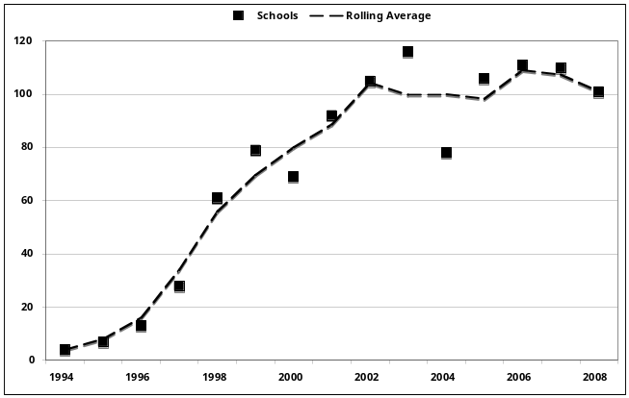
Figure 1 Total numbers of schools that participated in each year

The total number of students who have participated is considerable. In the period 1995 to 2008 alone, over 95,000 secondary students participated. As Figure 2 shows, these numbers also grew rapidly from 1999 to 2003 but have now stabilised at just over 10,000 participants each year.

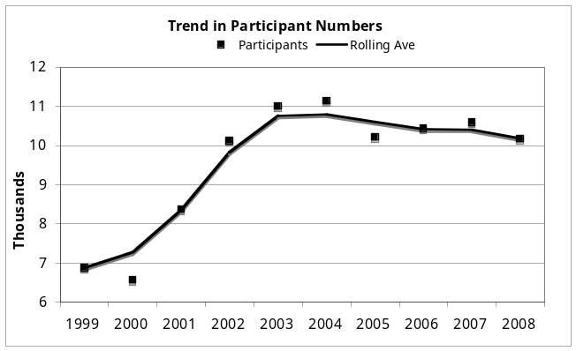
Figure 2 Number of individual students involved each year

Participation by System Type and Location
The most complete data on the characteristics of the participating schools is available from the year 2000. Figure 3 shows that participation by capital city schools has declined from around 60% to nearer 40% while schools in regional centres have increased their share of participation and now roughly equal capital city schools in number.

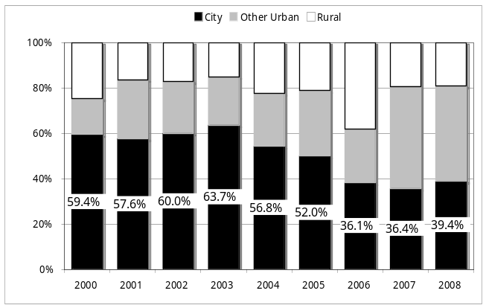
Figure 3 Participation by school location

Schools in rural areas have maintained their representation at around 20% of participating schools throughout the period.
Similarly, Figure 4 shows that, although they still represent the greatest share of schools that participate in the program, the share represented by government high schools fell throughout this period whilst the participation by independent schools grew to about a third.

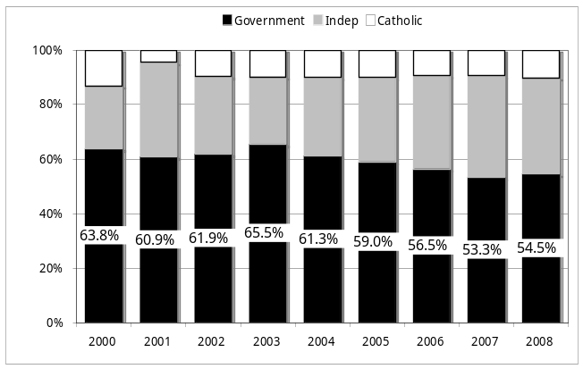
Catholic systemic high schools have remained static at around ten percent of those participating.
Figure 4 School participation by system type
School participation across the Australian states and territories has also changed in this period. The early growth in the program that followed the supportive funding of the Commonwealth government also spread the program widely beyond NSW with state coordinators having greater capacity to market the program’s value to local schools.
As Figure 5 shows, this meant that the NSW schools only represented about a third of the program in the period 2000-2004. Participation from South Australian schools remained high throughout the period but involvement by schools in the other states and territories declined after the position of the local coordinators could no longer be maintained.

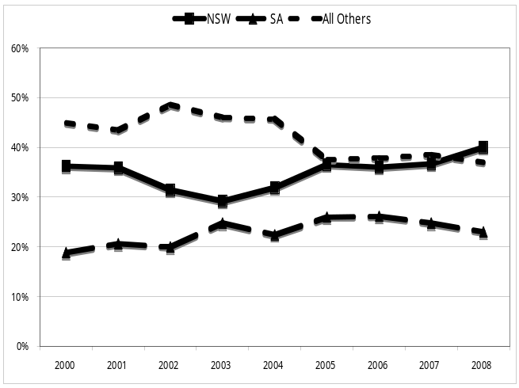
Figure 5 Program share by state/territory

The school year from which students are drawn
The ABW Enterprise Education program for schools was initially designed, and taken up by schools, for students in Year 11. Over time, however, this changed dramatically with Year 11 students dropping from 55% of all participants to just 30% (Figure 6) and the participation by all senior students (Years 11 and 12) dropping from 66% to 34%.
In the period since 2000 by contrast, the participation by Year 10 students grew from 40% to 65%. Anecdotally, this appears to be a response to the growing emphasis on the importance of the senior secondary certificate and unwillingness by schools to take any time away from preparation for that final certification.
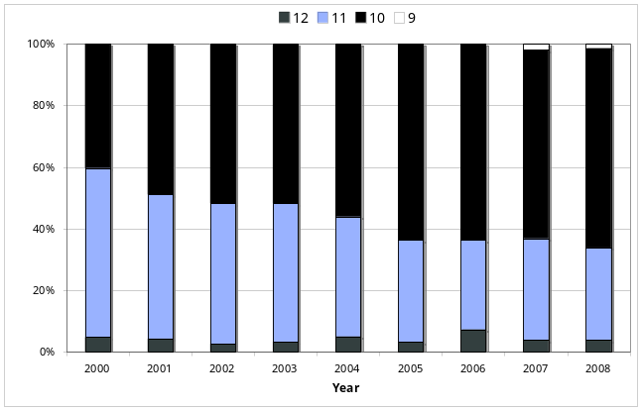
Figure 6 The changing focus of the program
Despite this change, there has been a much smaller than might be expected change in the average age of the participants. Figure 7 shows that their average age only decreased from 15.8 in 2000 to 15.7 in 2008.
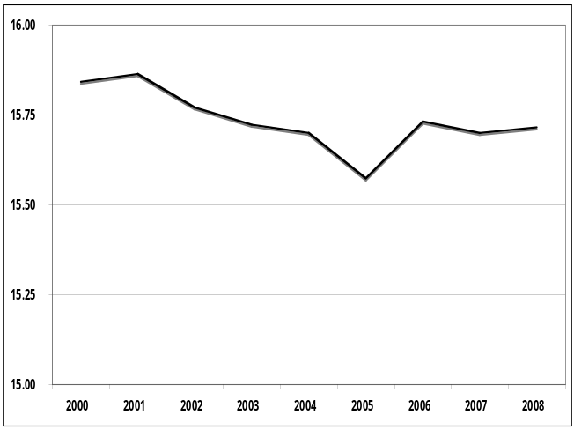
Figure 7 Age of school participants
Most of the changes and shifts in the focus of the program noted here have their origins in the changing context of schooling in Australia. Many schools report that the secondary curriculum is becoming increasingly crowded and that they have difficulty in including anything that is not a part of the accredited program. Indeed many find it difficult to accommodate any curriculum initiative that is not part of the core assessable curriculum mandated by state/territory officials. This situation is especially the case at the senior secondary level and many schools have chosen to offer the ABW Enterprise Education programs in Year 10 directly as a consequence of these pressures.

The Students
The data in this chapter is derived from the 34,797 pre-program surveys returned by secondary school participants in the program between 2000 and 2008.

Participant Age and Gender
Throughout the period, girls have remained the majority gender amongst participants. While, as Figure 8 shows, this has fluctuated somewhat over time, girls have typically represented about 54% of all participants.
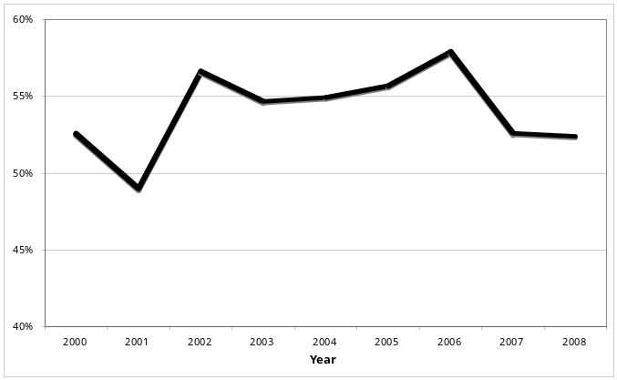
Overwhelmingly, the students who participate in the program are aged either 15 or 16 (86%). Figure 9 shows that less than 2% are aged over 17 years of age. As shown earlier, this has changed little throughout the period that the program has been in operation.
Figure 8 Gender of the participants

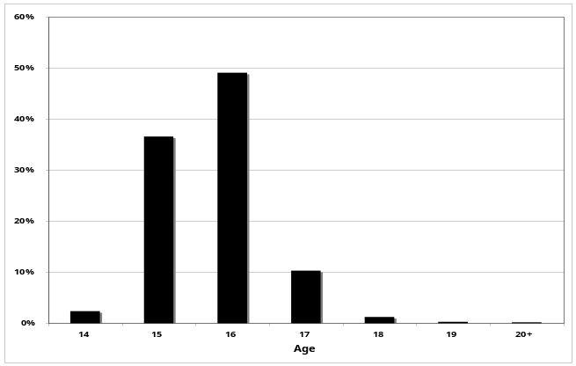
Figure 9 Age of participants

Other demographic descriptors of the student participants
As part of the pre-program survey of students they are asked a number of questions about themselves and about their families. This data gives us a good picture of the group of students who undertake the ABW Enterprise Education schools program.

Table 1 Demographic description of student group
Characteristic | Percentage
Parents were born overseas | 38.9%
Are Aborigines or Torres Strait Islanders | 1.7%
Are studying business-related subjects | 38.3%
A family member runs or manages a business | 55.1%
Has a part-time job | 42.9%

In the period since 2000, all but one of these demographic variables remained fairly static. The exemption is the proportion studying business-related subjects.

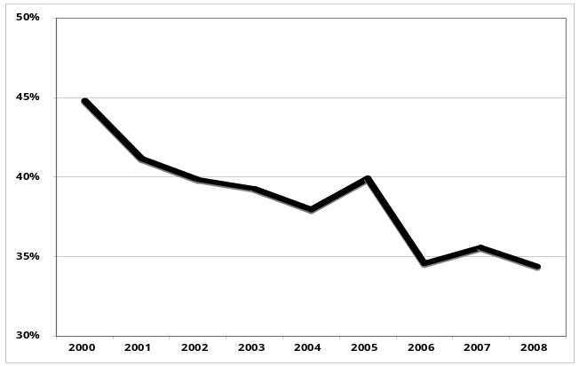
Figure 10 Proportion of students studying business-related subjects

As can be seen in Figure 10, this proportion steadily declined over the period to just over one-third in 2008. However, this is in keeping with ABW’s philosophy that the program is offered to the whole cohort not just to students studying business related subjects.

Student expectations about business and enterprise
Also in the pre-program survey, students are asked a range of questions that address their attitudes towards business and enterprise and their knowledge of it.
Students are asked to rate their standing on a nine-point scale in which 1 represents “no agreement” and 9 represents “high agreement”. For the purpose of the following analyses, ratings of 7, 8 and 9 have been combined to represent agreement with the various statements.

Table 2 Proportion agreeing with statements about business
Question | % agreeing
I know how to find out about a career in business if I want to | 53.6%
I have a good understanding of how a business operates | 37.6%
I understand why businesses need to make a profit | 84.7%
I have skills and abilities that would be useful in business | 56.1%
I usually finish what I start | 68.5%
I could give a short talk to a group of people | 42.1%
School has a high priority in my life | 65.5%

Of these questions, a clear trend over time is apparent for the question about the students’ perceived understanding of business operations. Figure 11 shows that, more recently, students have been more likely to agree with the statement than in earlier years (r = 0.43, p<0.01). Given that the proportion studying business has declined in the same period, this may more strongly reflect an unwarranted optimism than it does any real increase in awareness.

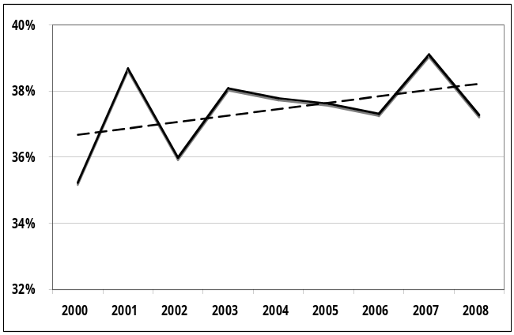
Figure 11 Trend in proportion agreeing they have a good understanding of business

The students are also asked questions about whether “in the future, they'd like to run a business” and asked to use a nine-point rating scale from 1 = “Definitely” to 9 = “Never”. Over the nine years surveyed, 41.5% responded with a 1, 2 or 3 rating to this question and this was found to vary considerably but with no clear trend over the period as Figure 12 shows.
Students are also asked to rate “How many of your skills are relevant to business” on a 9-point scale from 1 = “Most” to 9 = “Very Few”. Less than one in three students give this question a 1, 2 or 3 rating indicating a belief that their skills are relevant to business. However, over the period, this proportion consistently rose (r = 0.93, p < 0. O1) as Figure 13 shows.

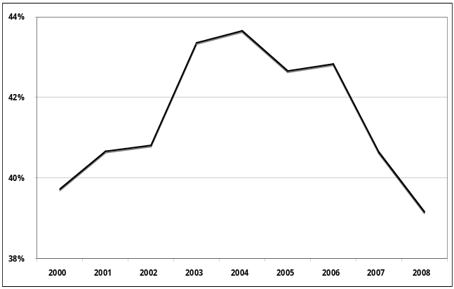
Figure 12 Expectation of running a business

This is consistent with the upward trend in the proportion regarding their understanding of business operation to be good, but does not appear to be related to their expectations about operating a business in future.

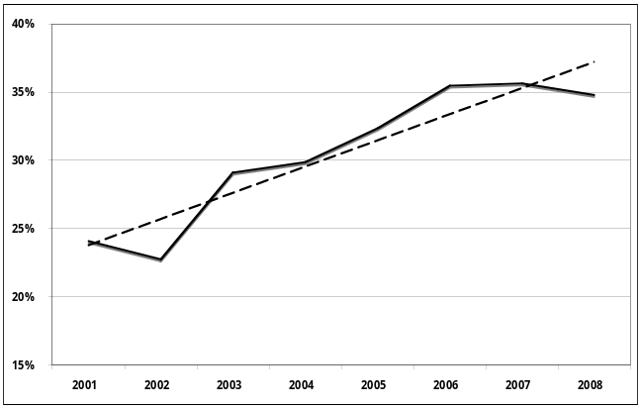
Figure 13 Proportion believing they have skills relevant to business

Business Attitude Scales
With the changes to the questionnaire forms introduced in 2004, two scales were developed to enhance ABW’s capacity to monitor and report on post-program changes in student attitudes. These two scales were a Business Capability scale that sought to assess student’s attitudes towards their capacity to operate a business and a Business Attitudes scale that assessed their attitudes about what working in a business would be like.
The Business Capability scale is comprised of seven items and was found (using the 2004 cohort) to have a reliability of 0.76 (Cronbach’s Alpha, n=4,779). Over the five years 2004-2008, 20,982 students returned pre-program questionnaires that enabled scale scores to be determined. These showed the scale to have a mean of 46.1 (sd = 8.5) and the distribution shown in Figure 14.

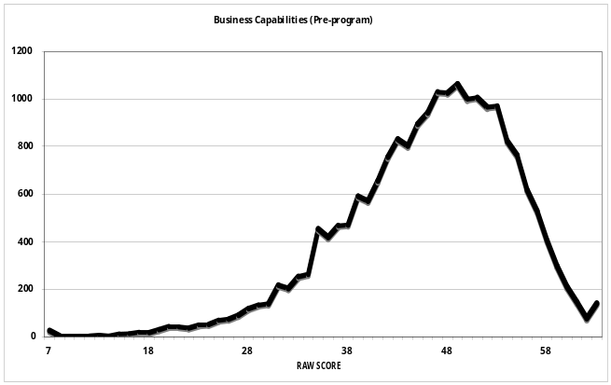
Figure 14 Business Capability scale

As this shows, the scale scores are skewed towards the upper end of the scale indicating that, as a whole, students believed themselves to be fairly well prepared for a career in business.
The Business Attitudes scale also involved seven items in which students were asked to rate the extent to which they would expect to find that working in business would be “exciting”, “stressful”, “creative”, “independent”, involve “risks”, “creative” or “routine”. Again using the 2004 data, the reliability of this scale was found to be high (Cronbach’s Alpha = 0.77, n = 4, 618).
Over the five years, 20, 982 students returned full scale data and this showed the scale to have a mean of 39.5 and a standard deviation of 7.9. As Figure 15 shows, the distribution of this scale is not as well behaved (it has a local mode at a raw score of 30) but is otherwise also skewed so as to indicate that students are generally positively-disposed towards business.

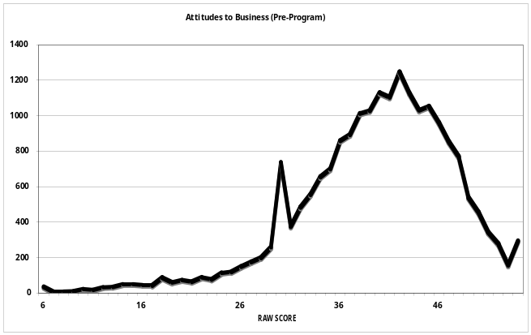
Figure 15 Business Attitudes scale
In a later chapter we will explore how the distributions of these scales change after the students have completed the program.

Teacher, Business Mentor and Parent Views
A central component of the initial (1998) evaluation of the program was direct contact with teachers, parents and business people involved in the ABW program. Following that initial study, no further research has directly addressed these groups. However, ABW Ltd has continuously collected data both directly from schools and from reports of ABW programs in local press and other media. This chapter primarily draws on the 1998 data but supplements this with more recent evidence on parent, teacher and business views.

Teacher views
The ABW program is designed to be as much an educational experience for school staff as for their students. In particular, it is expected that teachers will increase their understanding of the role of business and acquire a holistic view of business and knowledge. To explore how their involvement in the program had impacted on them, teachers were asked to indicate what was the main impact of the program on them.
The majority of responses were extremely positive. For some, especially those who had the role of coordinator, they indicate that their initial response was that the program was "a headache" or gave them "ulcers" or "sleepless nights". However, they quickly went on to say just how much they’d benefited personally and professionally from the program and what an insight they’d gained into their students.
Teacher responses can be grouped as follows:

Student achievement
It gave me the opportunity to see students I knew who would not succeed in subjects succeed and get something out of it - it was great to see how students thrived on the challenge, the team work, their enthusiasm, the interest from other students
Seeing kids really become interested, 33 in a group for a whole week not to have one absent.

Awareness of business and other subjects
It was an eye opener for me to see the nature of the challenge
I thoroughly enjoyed it - I got a new insight into the world of business
It developed my own personal confidence in dealing with business people

Enhanced status
It was a good marketing tool for the Business Studies area
We have the staff on side - 30 teachers involved. It has done great things for my position - I am being valued for giving a great product

Impact on teaching
We developed the same skills as the students did - the group was good for the teachers too
I leant how to not be a teacher, but a mentor
It showed me the importance of teaching to outcomes - I would have given the students more guidelines and checked half way on their progress
I try to incorporate a lot more teamwork especially at the younger age levels
A few teachers, however, noted that the program had not changed their teaching, either because they had already been student-centred or because they didn't have time to implement group work and experiential learning.

New attitudes to students
I view the students more positively
It opens your eyes to how resilient they are
Seeing students in a different setting and working with them in a different way
I was thrown in at the deep end, I didn't know anything about business and I was on the same level as the students
[students] absolutely blossomed - one was a true leader, his abilities were incredible
Because it's different it gives you another look at the students and better than that it gives the students an opportunity to look at themselves again in a new light
Indeed it was common for teachers to report that they learnt more about some students in those few days than they had in years of normal classroom practice.

Overall
Excellent in a word
I think it’s really worth the effort
It should be absolutely compulsory
It (the program) improves the school's image, it reaches the wider community, it sets up good relations between parents and staff - it has done great things for my position - I am being valued
The aspect of the program most commonly mentioned by teachers was that students respondents talked about the team skills and leadership aspects (and groups working towards a common goal) fostered by the program.
Students working in a group, it’s a very positive thing
The whole concept of teaming
Students are able to work in teams, see how teams operate
Team aspect, dealing with people, learning to compromise and cooperate
Teacher comments indicated that the program had brought home to students the importance of team work required in business and opened up the students’ understanding of the variety of roles which were available to them in business as part of an interdisciplinary team structure.
They realised there were other jobs in business – it changed their choices
Better student understanding of financial constraints and decision-making processes
Teachers interviewed indicated that the program definitely enhanced students’ ability to work in a team. This included new awareness of delegation, team roles, the contribution of individual strengths and weaknesses, the realisation that one person couldn’t do it alone, the realisation of how difficult it was to work in a team and the importance of good leadership. Comments include:
Yes, kids that don’t usually hang around together produced good quality work, they saw they could work together
Certainly did, (they saw) the importance of every person doing their bit
The students form companies – it gives them the opportunity to work under pressure in a short space of time and produce goods; they realise that one person can’t do it all - they realise the importance of delegation and leadership

Business views
Business mentors give varying amounts of time to the program. Some provide input to the plenary sessions on specific business topics, others provide support to one or more teams during the decision-making phase, others are judges on the final day. Beyond providing the young participants with insights into the real world of enterprise, it is hoped that the mentors themselves will:
- improve their own business knowledge and awareness
- increase their understanding and appreciation of schooling
- enhance their perceptions of young people.
The 1998 evaluation found that these objectives were being met but not to the extent which might be hoped. Schools find attracting and retaining business mentors difficult. This is not, however, because the business mentors don't find participation in the program to be rewarding. Rather it reflects the realities of business in the current economic climate and the demands the program makes on their time. As well it is a reflection of the rapidly growing demand schools are making on businesses as other forms of Enterprise Education and VET in Schools programs expand.
However, those business mentors who did become involved were overwhelmingly committed to the program.
I can't speak highly enough of it
Excellent. Kids seemed to really enjoy it and it gives them a good perspective of the business world
… school doesn't prepare them [students] for the business world - this helps
Should be more opportunities for this [schools & business coming together] to happen
Very impressed with students' ability and team development
I've never seen anything like this before — I was very impressed
Like teachers, business mentors saw the best part of the program as its use of teamwork and the skills students learnt about working together.
The team began with one clique and a few individuals and ended with them all hugging and kissing
[It] brought together kids who would not normally be together
… the fact that they were conscripted to a team rather than choosing the team themselves is a very important factor
Kids say ‘I've never worked with half these kids and I'm having a great time’
The second major theme noted by business mentors also reflected teacher views and related to the unanticipated development of individual students.
One girl didn't fit into the cliques but persevered and excelled. She was ‘tickled pink’.
It builds confidence, especially in those kids who take roles as public officers
I've seen kids who on Monday say ‘Gee what are we doing here - another bludge week’ and on Friday are pumped up and totally involved
The third theme of business mentors comments relates to the value of the program in linking students with the real world of business. Typical comments are:
It bridges the gap between the way business is taught in schools and what happens in practice
It takes away the mystique of business
… they come to realise that many business decisions are made 'on the fly' — you have to keep ahead of other companies and act quickly
[students come to realise that business is] more than just going to work
They have little understanding of cost structures … they think the boss is a millionaire because they took $1000 at the till that morning
For business mentors, too, the program was a learning experience and many commented on how it had benefited them.
I learnt something about how people can make huge shifts from one work paradigm to another
It helped me to come back to basics
[It] reminded me that school students are not much different from people in the workforce — just a little younger
In subsequent years, both ABW and specific schools have been approached by a number of businesses to have large groups of their staff participate as mentors because of the value of the program as staff development.

Parent views
The 1998 evaluation did not specifically canvas parent views though some insight into these was gained from teacher responses. One theme that did emerge was that parents were commenting that their children — often reluctant school attendees — were leaving early to get to the ABW program and/or staying late when critical decisions were due. Many expressed the view that nothing else at school had excited their children as did the week of ABW.
ABW was unknown to myself, until my daughter got involved and participated in what I acknowledge now as one of the most successful programs partaken by the school
(Parent, Elanora SHS as quoted in Best School Program submission)
I came home from work on Monday and my son was bouncing around all excited about the business he was running. He sat down and told me all about it and asked what I thought (as I run a business myself). He even gave up his Army Cadets because he 'was really into his homework'. Russell received a certificate for the best oral presentation and it has built his confidence which has been down this year.
(ABW website, original source unknown)
The extent to which Joshua enjoyed and benefited from the program is reflected in his increased ability to participate in groups, particularly at a leadership level, and in more confidence and self assurance which is reflected in his schoolwork and relationships.
(ABW website, original source unknown)
As the week progressed it was a pleasure to see my son displaying growing enthusiasm for the information he was acquiring and the skills he was developing….above all he had a great deal of fun developing and learning in a practical way, as part of a well-structured team.
(ABW brochure, original source unknown)

What Students Think of the Program
After completion of the program, the student participants are asked to report on their experience of the program. This involves an assessment of the program overall and of its several components.
Throughout the period in which the program has been evaluated over three-quarters of all participants rated “the program overall” as “Good” or “Excellent”. For the 2000-2008 period, with a total of 33,994 students supplying ratings that figure was 76.1% (see Figure 16) and throughout the period since the 1998 evaluation the figure has not fallen below 75%.

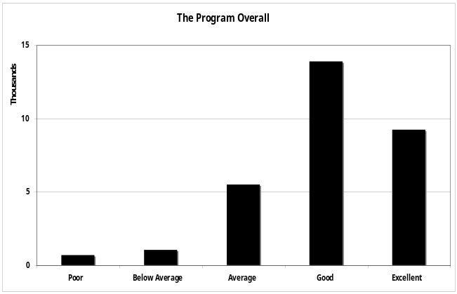
Figure 16 Overall program ratings 2000-2008
Moreover, students are asked to indicate whether or not, as a result of their experience, they’d recommend the program to others. Almost nine out of ten participants indicate that they would recommend the program.
This proportion (as Figure 17 shows) has remained highly consistent and indicates an unusually strong level of support. (Note 2000 data is not available due to a data entry error that omitted data for this question).

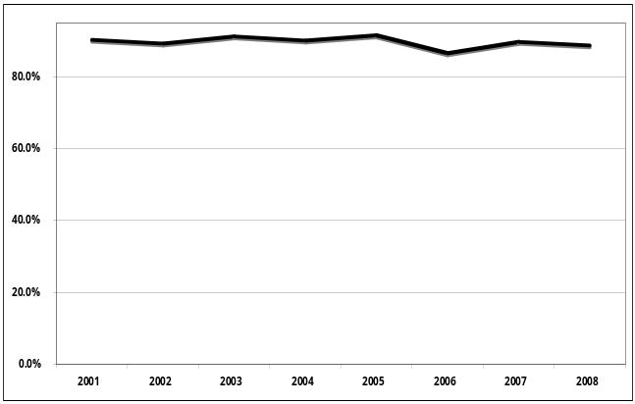
Figure 17 Proportion recommending the program

The students were asked to rate their view of each of the components of the program on a five point scale where 1 represented “Poor”, 2 = “Below Average”, 3 = “Average”, 4 = “Good” and 5 = “Excellent”.
Data from over 30,000 students (the exact number varies slightly between questions) provided usable data and this (with their average overall rating) is shown in Figure 18.

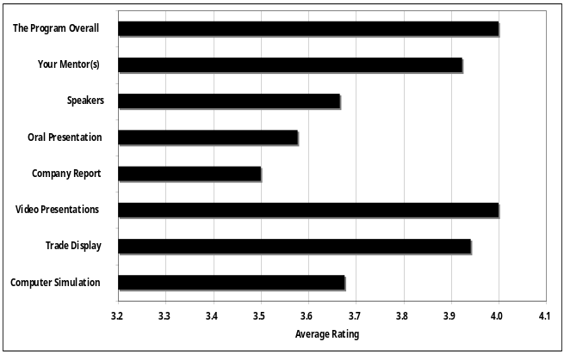
Figure 18 Participant evaluations of program components

As with the rating of the overall program, around three-quarters of respondents rate each program element “Good” or “Excellent”. The least attractive component is the Company Report and, for this element only 54.2% gave it this high rating.
However, as can be seen in Figure 19, average ratings for each component have remained quite steady over the years with the exception of the participants’ evaluation of the speakers, which noticeably increased from a low in 2001 and 2002. However, this too has remained fairly steady since. (Note: because of the large sample sizes, the differences in the mean ratings for most of these questions are statistically significant, but only for Speakers, is the degree of change of any practical significance.)

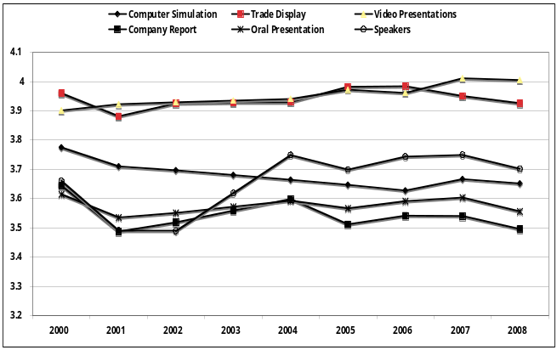
Figure 19 Ratings of program elements over time

What the students say
A key component of the evaluation of the 1998 program involved talking to students and collecting their written comments on the evaluation questionnaires. This showed that students typically recognised the value of the program and found it enjoyable. Typical comments included:
It was great and I would do it again
It should be done every year
It helped me learn more about myself and others
Students were asked to respond to the program and each of its major features. The following comments are typical of what students saw they liked about the program:
Using skills I didn't know I had
How to do things I never thought I could do
One of the few aspects of the program which students found less than satisfactory was the pressure of the week-long commitment that the program involves. While some saw this as a reflection of the real business environment, others found this more problematic.
Need more time to do it better
Stressful!!
Very chaotic
However, as has been the case throughout the eleven years of data collection, the overall response was summed up by one student who said:
the program was "the best fun I ever had".
The team captain who had led the winning team in his school in the 2009 competition summed up his own and his colleagues experience on their school’s web-site. An extract from his statement reported:
What I enjoyed most about A.B.W was the quick thinking needed and the rush to hand in our quarterly reports on time. There were days I had to force myself to talk louder, write faster and think better so my team could follow instructions. Then there’s those last 10 minutes where you walk down the hall with all the other stressed C.E.Os to enter your results on the hotel computer simulation. You begin to question yourself - did I put the right debentures? Did I invest enough in advertising? Have I given enough dividends to my shareholders? I know I’ve learnt a load from A.B.W as I didn’t even know what these questions meant at the beginning of the competition.
http://web3.homebushbo-h.schools.nsw.edu.au/component/content/article/1-latest/430-australian-business-week

How Students’ Knowledge and Attitudes
Change After the Program
An important feature of the design of the evaluations has been an attempt to assess what impact the program has on student attitudes and self-evaluations. This has been done by the inclusion of the same questions in both the survey form that students complete before they commence the program and also in the form they complete after the program has been run.
While, it would be ideal to track the longer-term impact of the program this time interval of around two to four weeks has proven to be a practicable arrangement in the complex and demanding lives of schools. Of greater significance to our capacity to assess impact has been the insistence of many schools that the surveys be completed anonymously. Thus no data uniquely identifies student responses making it impossible to assess change at the individual level. This allows a much less powerful test of change than ideally might be had. Despite this limitation, reports from the series that began with the evaluation of the 1998 cohort have been able to demonstrate what changes are found following the program. This chapter provides an overall view of these and presents new data that combines all of the data from 2000 to 2008.

Changes in individual questions
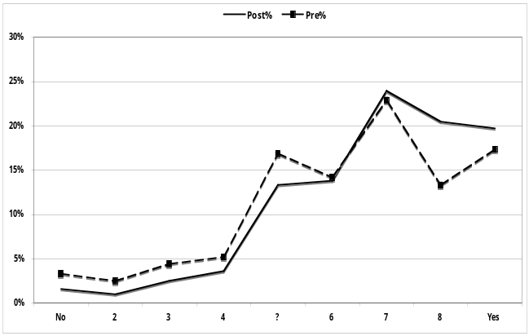
It is interesting to find that the experience of undertaking the ABW Enterprise Education does tend to make the students more positively disposed to enter a career in business in future. Thus, for example, Figure 20 shows that while the participants initially believed that they had a fairly good prospect of “find[ing] out about a career in business if I want to”, the students are rather more likely to respond in this way after completing the program.
Figure 20 Pre and post program ratings - Career Information

But this tendency for the students to show a more positive stance following the program is not seen in other questions. For example shows that prior to undertaking the program students were fairly evenly spread when asked if “In the future, [they]'d like to run a business”, but were slightly more likely to respond towards the “Definitely” end of the scale. Following the program, however, the students remain widely spread but the graph has tilted somewhat more towards the end indicating a lesser intention to engage in business in the future. This suggests that the experience of the program may give students a more realistic appreciation of their interests and has led many to re-assess their career prospects.

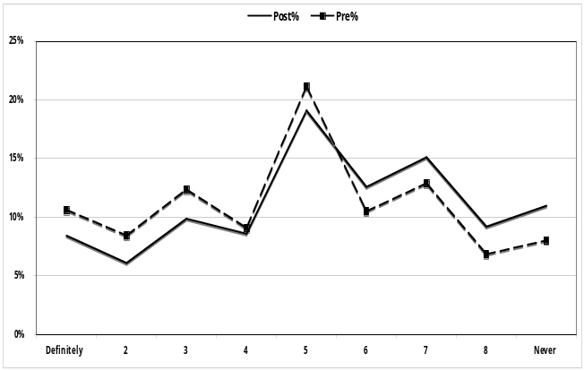
Figure 21 Changes in intention to run a business in future

This pattern of change is also found in the students’ responses to the question “How many of your skills are relevant to business?” Here, students show that they become aware that a fewer of their skills are of use in business than they had originally (perhaps optimistically) expected (Figure 22).

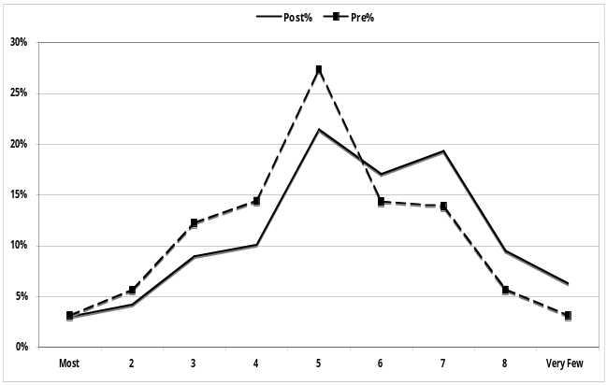
Figure 22 Rating of extent skills are relevant to business

This data provides strong evidence that the program has an impact on the students who participate with a significant proportion of the participants demonstrating a new and deeper understanding of their own skills and abilities and of the relevance of these to the world of business activity. This interpretation is given further strength when we look at the ways in which participants’ change their responses to the scales that have been developed.

Changes in student attitudes
These scales were developed to reflect, firstly, the students’ attitudes towards their own capacities and their relevance to business practice and, secondly, their attitudes towards working in a business.
Figure 23 clearly shows that the intervention of the program resulted in students reporting a significantly more positive view of the extent to which their skills are relevant to and useful in the world of business.

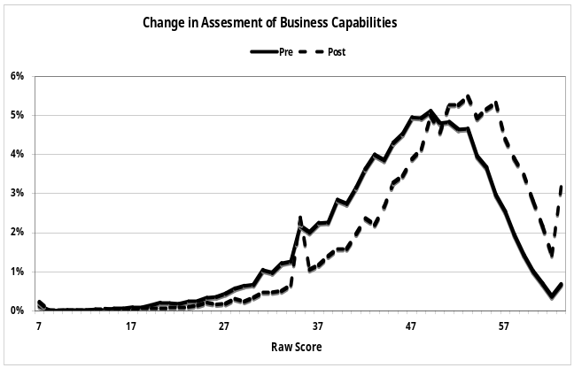
Figure 23 Impact of the program on Business Capability scale

The effect of undertaking the program on responses to the Attitudes to Business scale (Figure 24) is very much less marked. Students are slightly more positively disposed towards working in a business post-program but the size of the change (while statistically significant) is much smaller than for the Business Capabilities scale.

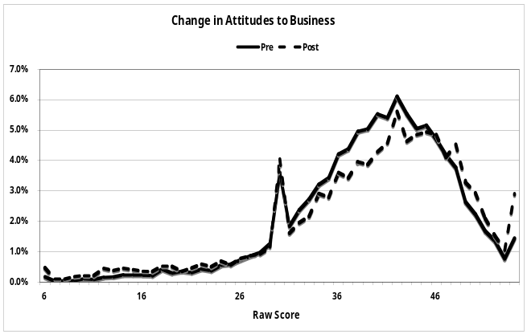
Figure 24 Impact of the program on Attitudes to Business scale

In line with the findings of previous research in this series (see those reports for more details), Figure 25 shows that the changes that occur in the distribution of scores on the Business Capabilities scale are influenced by demographic factors, in this case the type of region in which the participant’s school are located.
To facilitate comparison, the Business Capabilities scale was divided into three roughly equal size groups on the basis of the pre-program scores for the full data set (n = 31,870). Thus, three score groups were created, Low = score of 42 or less (lowest scoring 30.5% of pre-program participants), Medium = scores 43 – 49 (next 36.5%) and High = scores of 51 or above (the remaining pre-program students). These same cut-offs were then used to categorise post-program scores for this scale.
The figure shows that, for each school type, the proportion categorised in the upper (High) group rose from approximately one-third to well over half. In particular, the change was greatest in those students who attended schools in urbanised regional areas outside capital cities.

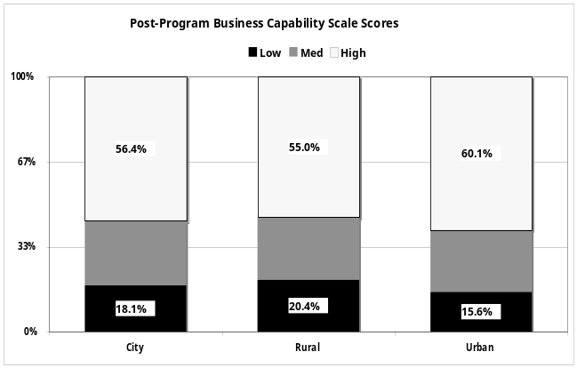
Figure 25 Effect of school location on post-program changes

This data clearly indicates that attendance in this program shifts students’ ideas and attitudes. Before embarking on the program students appear to have a view of business that is founded on relatively little real experience. Over the course of the week, they come to understand their strengths and weaknesses more astutely and to develop a more nuanced and informed understanding of business.

Some Explorations of the Influence of Demographic Variables
Over the course of the evaluation program, it has been identified that the demographic variables collected as part of the evaluation questionnaires provide useful and interesting insights into the changing population of participants and the influence these variables can have on the students’ awareness of business and enterprise and their attitudes towards it and about their own capabilities.
This chapter identifies some of the ways in which both published and unpublished research arising from these evaluations has explored the effect of these demographic variables.

Impact on student experience of business
This section draws on data from the evaluations and uses data provided by over 10,000 students accumulated from programs offered over the four years of 1998-2001. It uses a data analytic technique called Formalised Inference-based Recursive Modelling (FIRM) (Hawkins & Kass 1982), a contemporary version of the AID methodologies developed in the 1960s. Essentially the approach involves successively subdividing the sample on the variable that maximises the differences within the sample on a specified criterion. This allows for the relationships between variables to be easily understood without requiring assumptions of linear relationships among the variables.
Figure 26 Percentage of students whose parents or relatives own or operate a business
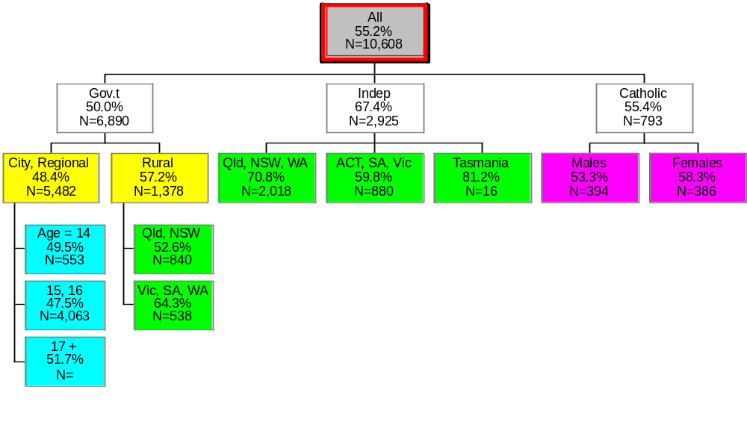
Amongst the questions included in the surveys, students were asked to indicate if their parents or other relatives owned or operated a business. Figure 26 examines how various of the demographic variables impact on the proportion of students who answered this question affirmatively. The type of school system attended by the students was the single most important factor that differentiated amongst the students with the students attending Independent schools being significantly more likely to indicate that family members were engaged in business. However, within each of the school system groups, different factors operate to differentiate levels of family involvement. For Government school students, for example, school location is the next greatest differentiator with students from rural schools having significantly fewer family members involved in business than do their colleagues in capital cities or regional centres.
Similar results apply when students are asked to rate the extent to which they believe they “understand how a business operates”. Figure 27 shows that gender is the primary differentiating variable.

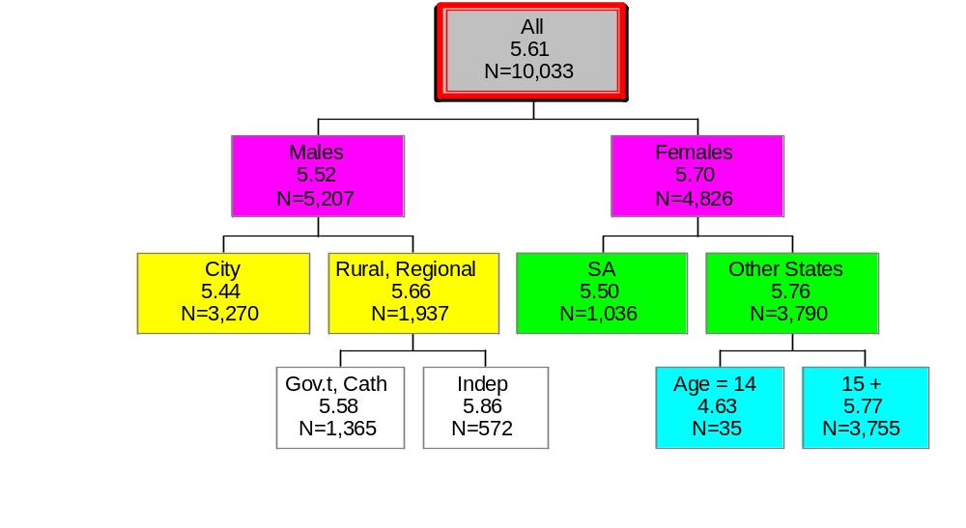
Figure 27 Average rating on understanding of business
These and a range of other analyses have been reported in a 2003 conference paper (Hawke 2003a).
Similar effects of these demographic variables have been found to operate when we examine the impact of the program on the changes in participants’ responses between their pre-program answers and those they give after they’ve undertaken the ABW Enterprise Education program.

Effects on pre-post change
For example, as part of the pre-and post-program surveys, students were asked to indicate the extent to which they agreed with the statement “I know how to find out about a career in business if I want to”. For the purpose of these analyses the nine-point rating was dichotomised and the following tables report the difference in the percentage of students who responded positively to this question before and after the program. A positive figure indicates that more students gave one of the three most positive ratings after completing the program than had been the case before.
Overall the many possible sub-groups, 10.4% of students change their rating from a neutral or negative assessment to a positive one.

School location & system type
In this analysis of data from 4,076 participants in the 2004 cohort (not previously reported), the increase in the proportion that gives a positive response to this question is separately tabulated by each combination of school location and school system type (note: in this sample, no rural students attended Catholic systemic schools).

Table 3 Effect of location and system type on access to career information
 |  |  | Location
 |  | City | Rural | Urban | Total
 | Cath | 12.9% | N/A | 5.8% | 10.6%
Type | Gov | 12.5% | 6.6% | 13.2% | 11.3%
 | Ind | 8.2% | 13.3% | 8.2% | 8.6%
 | Total | 11.2% | 7.4% | 10.2% | 10.4%

This clearly indicates that some combinations of location and system demonstrate either substantially higher or substantially lower than average degrees of change from pre-program levels.
Using the Weighted Net Percentage Difference technique (Spady 1970) allows for the assessment of the effect of one variable, while holding others constant. Thus, controlling for School location, the effect of the different school systems alone is:
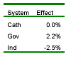
Thus, around 2% more Government school students typically shift from a non-positive response to this question to a positive one while 2.5% fewer than average students from independent schools do so.

Controlling for School system type, the effects of various school locations are:
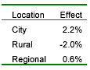
City and, to a lesser degree Regional, students are more likely than average to show improvements post-program. Students from Rural schools are less likely to adopt a more positive stance after undertaking the program.

Similarly, the effect of gender and school grade level can be shown to have implications for the students’ ratings of their understanding of how a business operates. Overall, 31.6% more students rated their understanding to be in one of the three top categories (of 9) after completing the program.
Table 4 shows that there are considerable differences in the individual cells when the gender mixture of the school and the grade level of students undertaking the program are cross-tabulated. Notably, the combination of mixed grade levels being involved in co-educational schools results in a lower rate of change than is typical of the sample as a whole.

Table 4 Changes in proportion responding positively about understanding business operation
 |  |  | Gender Mix
 |  | Boys | Co-Ed | Girls | Total
 | Junior | N/A | 34.6% | 35.3% | 34.7%
Grades | Mixed | N/A | 23.9% | N/A | 23.9%
 | Senior | 34.3% | 28.1% | 28.4% | 28.7%
 | Total | 34.3% | 31.6% | 31.3% | 31.6%

The raw marginal percentages don’t vary a great deal, so it is important to consider the effects after other variables are controlled. Firstly controlling for the effect of gender, the remaining effects of the mixture of grades in the program are:

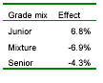
The Grade effect is quite great. A program involving Junior students only is substantially more likely to result in a positive change while a program involving only Senior students or a mixture of grades is likely to see substantially fewer students changing their response in a positive direction.

In a similar fashion, when the effect of the mixture of grades is removed, the effect of different gender mixtures in a program is found to be:

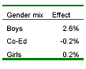
The greatest change is likely to occur in boys only programs while Co-Ed or Girls only programs don’t appear to be associated with percentages of change very different from the average.

These analyses represent simply some of the rich data that this evaluation has provided and an indication of the sorts of insight into the relationships that may affect the ways in which school enterprise education programs impact on participants and their future choices.

Conclusions
The substantial body of data that has been accumulated since the first evaluation of the ABW Enterprise Education program for schools in 1998 has provided an unequalled insight into the program, its effectiveness and the many factors that shape student experience of the program and their understanding of, and attitudes towards, enterprise and business activity.
The data shows clearly that the program is highly regarded by the student participants and by teachers and the school community more generally. More than 75% of the students rate the program as “Good” or “Excellent” and almost 90% would recommend the program to others.
Students indicate that they find the program challenging but that they gain useful insights into themselves, their colleagues and into the world of business. Teachers, too, find the experience opens their eyes to aspects of their students they never or rarely see in the normal classroom environment.
Moreover, many teachers comment on the innovative teaching and learning approach that the program utilises and the possibilities it opens up for them. Unfortunately there does not appear to be any evidence that this changes teachers’ classroom practices and this is an aspect of the program that warrants further research.
Additionally, it is clear that the program is associated with changes in the level and kinds of knowledge the students have about business practices and operations. Following the program students are more likely to indicate they have a “good understanding” of business and are significantly more likely to consider owning or operating a business in future. Further, the participants appear to develop a more aware and nuanced understanding of their own skills and abilities and how these might be useful in a business context.
By consistently collecting the data from the pre-program and post-program surveys since the 1998 cohort, ABW has now accumulated a massive data set that is, probably, unparalleled in its size and in the breadth of information it contains. Research using this data set has only just scratched the surface of what might be possible and it is hoped that the data will be available for other researchers to explore in the future.

References

Hawke, G 1999, The Australian Business Week Schools Program: An evaluation, Commissioned Research Report, Sydney, Research Centre for Vocational Education and Training.
Hawke, G 2000, The Australian Business Week Schools Program: 1999 evaluation, Sydney, Research Centre for Vocational Education and Training.
Hawke, G 2001, The ABW Enterprise Education Program: A three-year review, Research Centre for Vocational Education and Training, Sydney.
Hawke, G 2002, The ABW Enterprise Education program: 2001 performance, Research report, Sydney, OVAL Research.
Hawke, G 2003a, 'Students in an enterprise education in schools program: Their experience of, and attitudes towards, the world of work', in The Changing face of VET. Proceedings of the 6th annual conference of the Australian VET Research Association, AVETRA, Sydney. http://www.avetra.org.au/abstracts_and_papers_2003/refereed/Hawke.pdf
Hawke, G 2003b, The ABW Enterprise Education Program 2002: A focus on school location, Sydney, OVAL Research.
Hawke, G 2004, Regional differences in the backgrounds of participants, operation of programs and outcomes for students: ABW Enterprise Education 2000-2003, Sydney, OVAL Research, University of Technology, Sydney.
Hawke, G 2010, Building enterprise skills: The ABW schools program 2000-2008, UTS Centre for Research in Learning and Change [unpublished], Sydney.
Hawkins, D M and Kass, G V 1982, 'Automatic Interaction Detection', in ed Hawkins, D. M., Applied Multivariate Analysis, Cambridge University Press, Cambridge, UK.
Spady, W G 1970, 'Simple Techniques for Multivariate Analysis or How to Amaze Your Colleagues Without the Aid of a Computer', Interchange, vol.1, no.3, pp.3 - 20

